King Fahad Medical City (KFMC)  Institutional Review Board (IRB)  Dhabab Street, P.O. Box 59046, Riyadh 11525, Saudi Arabia, Tel # 011-2889999 |  | 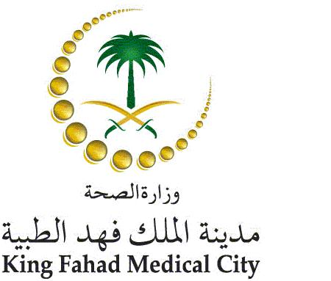
Invoice

Bill To: |  | Invoice #:
 |  | Due date
Study Title:
Service description: IRB submission Fees*
Amount: 7, 500.00 SR

Amount in words: Seven Thousand Five Hundred Saudi Riyals Only

Name of the account holder | Self Financing Fund Development at King Fahad Medical City
Banks’s name/branch name | Riyadh Bank\ King Fahad Medical City Tel 2889999 Fax Ext 1480
IBAN Number | SA9620000002480333359940
Bank SWIFT code | RIBLSARIXXX
* The IRB review process will not start before the transfer of the fee.

